
Toyota Motor North America Executive Scrum Board
Team 2 --- Scrum of the Earth
Toyota Project Customer: Troy Morgan
University of Kentucky --- CS 499 --- Fall ’17
November 12, 2017
Authors:
Logan Hickey – editor, author of review/metrics and coauthor of testing
Irsyad Hanif – author of user manual/source code
Thomas Wheeler III – author of admin manual and coauthor of testing
Jonah Starling – author of source code/commenting

Contents
I. Implementation 1
1. Source Code 1
1.1 Implementation/Comments 1
1.2 Quality Review 1
2. User Manual 1
2.1 Introduction 1
2.2 Board Overview 1
2.3 Adding Cards 2
2.4 Card Details 2
2.5 Editing a Card 3
2.6 Moving a Card 4
2.7 Deleting a Card 4
3. Admin Manual 5
II. Testing 5
1. Acceptance Testing 5
1.1 Test Plan 5
1.2 Test Cases 5
1.3 Quality Review 6
2. Unit Testing 6
2.1 Test Plan 6
2.2 Test Cases 7
2.3 Quality Review 11
III. Metrics 11
Current Lines of Code 11
Complexity 11
Product Size 11
Product Effort 12
Project Defects 12
IV. Site URL/Developer Notebook 12
1. Project Website URL: 12
2. Effort Log: 12
3. Team Meeting Log 12
4. Estimated Word Count 13

I. Implementation

1. Source Code

1.1 Implementation/Comments
We have made our source code with all commenting available from: https://github.com/irsyadhanif/ToyotaProjectBoard

1.2 Quality Review
Our team has completed our second scrum cycle. Up to this point we have not had a substantial problem with front end development. We currently have a live solution for Toyota to access. The problems that we are facing moving forward is with the database linking to the front end. We worked on this heavily for the past week and have moved to a second technology to attempt to create a solution. Our third sprint, based on feedback from our Toyota customer, will focus specifically around integrating the database so that data can be stored on our live site to be accessible for recurring sessions. They suggest to hone in on this one component, putting a pause on front end development, in order to obtain more “scrum-like” progress.

2. User Manual

2.1 Introduction
The Toyota Project Board will allow for upper level management to gain a better overview of the in-progress projects running within their department. Using Toyota’s classification of in-progress projects, the Project Board gives quick information on whether a project is on time, needs work, or is in serious trouble. Before, projects were placed into three columns on a white board, with VTC cameras pointed at the board if needed. This is obviously very low-tech, and unsuitable for board meetings with managers around the world. In addition, this does not show a lot of information about the project, nor does it provide an up-to-the-minute status of the project.
The implementation of the Toyota Project Board will remedy these problems. Any executive, regardless of technical level, can point his browser to the server hosting the Project Board, and begin to interact with the user-friendly Project Board. He or she can see what projects are in each category, the reason why they’re in that category, and any other details about the project. He or she can also create new cards, edit existing ones, or drag card to different categories.

2.2 Board Overview
When users open the Project Board webpage, they are taken to the overview of the board. Figure 1 shows an empty project board. The columns are colored, with red meaning in trouble, yellow meaning needs work, and green meaning on-time.


Figure 1: An empty project board

2.3 Adding Cards
Adding cards to a column is simple. Clicking on the black circle with a plus inside will create a default card for that column. While on the Board Overview, a card will show the title and a truncated description. Figure 2 shows the default card.

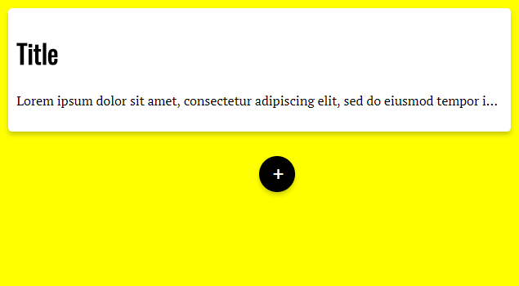
Figure 2: A default card added to the yellow column

2.4 Card Details
Clicking on a card will take you to a more detailed view of the card. In here, you will find the rest of the description, along with any other details on the card, such as project leader, team assignment, cost, etc. You will also be able to edit and delete the card from here. To exit the card detail, simply click on the outside of the card. Figure 3 shows the card detail page.
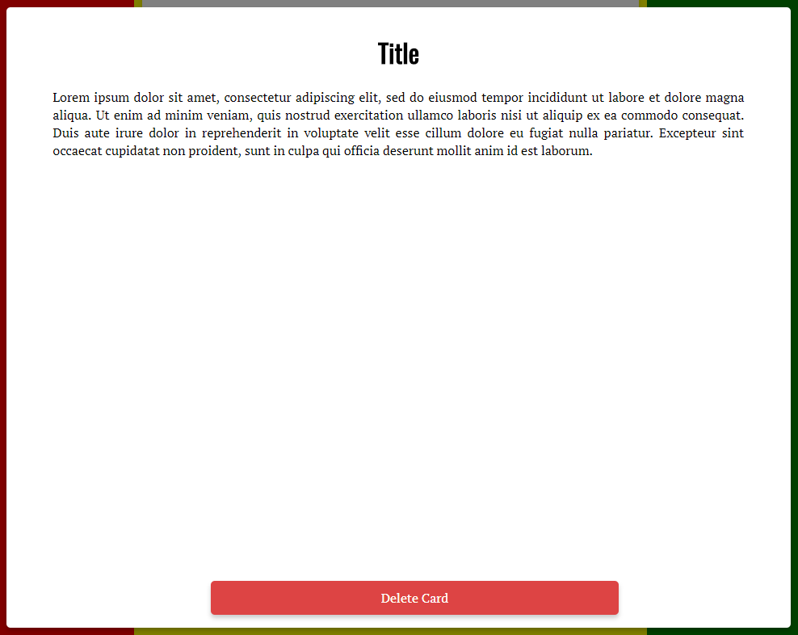
Figure 3: The card detail page, along with options

2.5 Editing a Card
To edit a card’s description or title, click on the description or title while in the card detail. A text box will pop up, allowing you to edit the original text. Figures 4 and 5 details changing the title of a card.
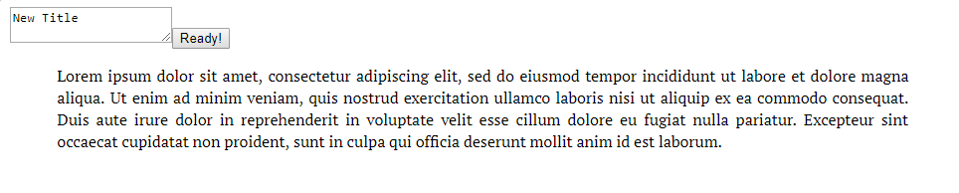
Figure 4: Editing the text box to say New Title…

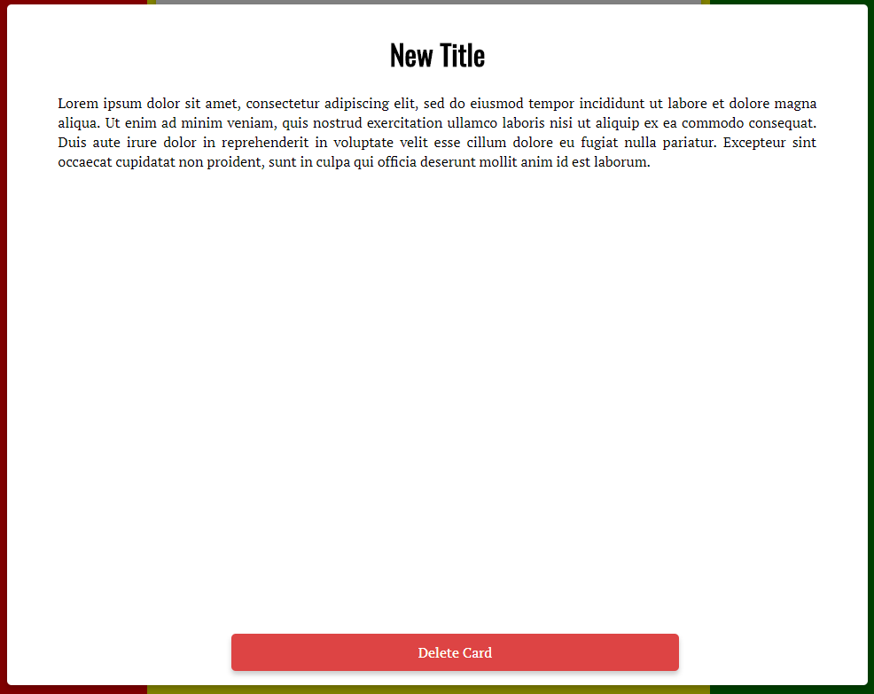
Figure 5: …and hitting ready to see the new title.

2.6 Moving a Card

The Project Board allows a user to drag-and-drop cards into different categories. Figures 6 and 7 shows how this can be done.
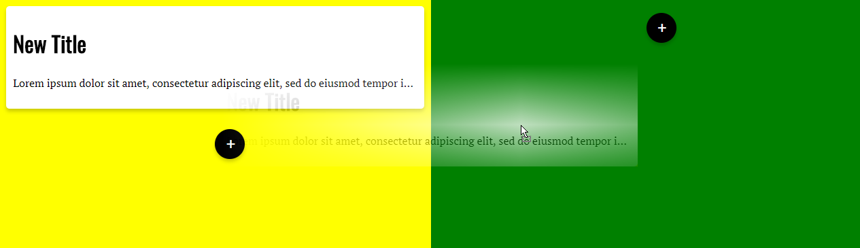
Figure 6: Clicking and dragging a card from the yellow column…

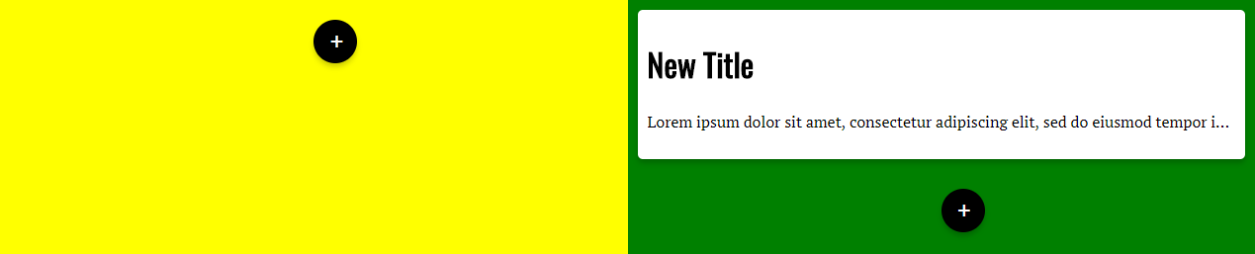
Figure 7: …and releasing to drop it into the green column.

2.7 Deleting a Card
The option to delete a card can be found in the card detail. At the bottom, click on the red “Delete Card” button to delete a card. Figures 8 and 9 demonstrate this.

Figure 8: Click on the delete card button…

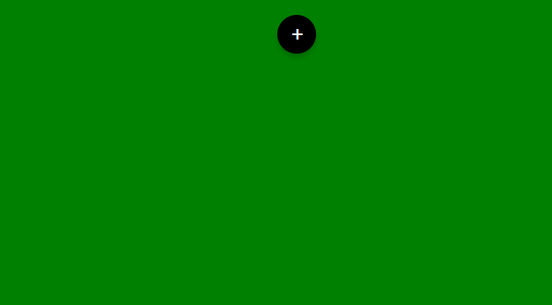
Figure 9: …and the card is deleted.

3. Admin Manual
Toyota wants to use our tool as quickly as possible, so we set it up as a password protected website running on UK Netlab. As a result, there is very little installation or configuration that Toyota needs to do in order to start using the tool right away. All we have to do is share the static password with them. This is a temporary solution as Toyota moves to consolidate their authentication solution. We were asked specifically not to create any type of sophisticated authentication solution as Toyota has plans to do this themselves down the road. Eventually, after the semester is over, Toyota plans to integrate our tool fully into their system, and use their authentication procedures. They will handle this integration and any associated installation or configuration requirements.

II. Testing

1. Acceptance Testing

1.1 Test Plan
Our Acceptance Testing plan is not static, but rather dynamic as our project has changed over its lifespan. As we developed features and added user stories, we added and removed various test cases as appropriate. The purpose of Acceptance testing is to evaluate our system's compliance with Toyota's requirements and expectations. Acceptance testing was used as a roadmap to determine where we need to focus our efforts in order to achieve the overarching goals of the project.

1.2 Test Cases

Case Number | Test Case | Success Condition | Failure Condition | Pass, Fail, Out of Scope
1.1.1 | Board exists with with 3 columns: red, yellow, green | Board exists with the three columns in the order Toyota wants | board does not exist | P
1.1.2 | Board functions similarly to trello in that cards can be created, edited, and moved | board functionality is similar to trello | cards cannot be moved, cards cannot be created, cards cannot be edited | P
1.1.3 | Project details can be easily seen at a glance | Project details, including title and major points can be easily seen without going into detail dive | details and top points are not immediately available | P
1.1.4 | Detail Dive can be brought up by clicking on a card | When a user clicks on a card, the details about the project appear enlarged in the middle of the screen so they can be presented for discussion | details about the projects are not available | P
1.2.1 | Titles and Descriptions of cards can be edited and saved | When clicked, the titles and descriptions of cards can be edited and saved | titles and descriptions cannot be changed or cannot be saved | P
1.3.1 | Board is accessible to Toyota | Toyota can start using our tool | board is not available to Toyota and they cannot use it | P
1.3.2 | Board is encrypted | The board is protected using some form of encryption | the board is not encrypted | F
1.3.3 | The board is password protected | There is a password in place which is necessary for accessing the board | There is not a password necessary to access the board | F
1.4.1 | The changes made to the board are persistent | Changes made are saved, and available after leaving the board | changes are not saved | F

1.3 Quality Review
As with our unit testing, our acceptance testing has not been systematic and relies on manual testing of the product. Due to the nature of Acceptance testing, our methods involved using the tool like Toyota would. We went through the process of creating cards, and moving them around, editing them, and going into detail dive. Toyota was very clear about their requirements and what they wanted to see, so we went through this list and testing our tool in the way we expected they would. We concluded that this would be the best approach rather than a systematic approach, because Toyota wanted to put our solution in play as quickly as possible and our chosen approach allowed us to get a functional product into their hands as quickly as possible.

2. Unit Testing

2.1 Test Plan
Our unit testing is a sort of living document. We intend to alter and add test cases based on future user stories, backlog items and bugs that we encounter along the way. Our current unit test cases are featured in the chart below. Many of our test cases we have not yet reached in development and are marked as out of scope (O). For all test cases that we have attempted or reached in the current scope of our project, we have indicated as pass (P) or fail (F) based on current live functionality. It should be noted that the problems with backend integration have inhibited our ability to deepen testing. This will soon change as we allow data to be saved to our database.

2.2 Test Cases
Case Number | Test Case | Success Condition | Failure Condition | Pass, Fail or Out of Scope
1.1.1 | name on card exists on click | card properly displays name when chosen via board | error displays saying a name to card has not been established | P
1.1.2 | move card on main board | card moves positions when clicked and dragged | returns error saying card cannot be moved | P
1.1.3 | exit button on card screen | exit button returns to main board | exit button returns error saying cannot return | P
2.1.1 | add text | add text button opens screen input screen | add text returns error saying text cannot be added to card | O
2.1.2 | edit text | edit text button opens text editor | edit text returns error saying text cannot be edited | P
2.1.3 | delete text | delete text button deletes text from card | delete text button returns error saying text cannot be deleted | O
2.1.4 | edit name | edit name button opens editor for name | edit name button returns error saying that name cannot be edited | P
3.1.1 | name storage | name is properly stored when editor is exited | error is returned saying name could not be saved | F
3.1.2 | text storage on card object | text is properly stored when editor is exited | error is returned saying text could not be saved | F
3.2.1 | card position storage | position of moved card is stored properly | error is returned saying cards new position could not be saved | F
4.1.1 | display name on card | cards name is displayed after change or initiation | error displays in place of blank name | P
4.1.2 | display text on card | card text is displayed after change or initiation | error displays in place of blank text | P
4.2.1 | display cards on board | card is displayed on board when initiated. | system returns error saying card cannot be created | P
5.1.1 | store initial account data | new data input into system is properly stored | error returns saying that new user ID could not be created | O
5.1.2 | alter initial account data | editor opens and correctly alters ID data | error returns saying user ID data could not be changed | O
5.2.1 | permissions able to be granted to cards/board | permissions can be granted to IDs | error returns saying user cannot be granted privileges | O
5.2.2 | permissions able to be removed to cards/board | permissions can be removed from IDs | error returns saying user cannot be removed of privileges | O
5.3.1 | admin established to control/alter permissions | admin can be established that has all access | error returns that admin cannot be created | O
5.3.2 | admin can be changed | admin can be changed following defined protocol | error returns saying correct admin change protocol was not followed | O
6.1.1 | allows login | login attempt is successful. | login error message saying ID not found | O
6.1.2 | success login leads to board | login displays boards | error returns saying no boards found | O
6.1.3 | allows new account setup | new account successfully established to server | error returned saying new account cannot be established | O
6.2.1 | add name | name can be added on new user page | error returned that name is taken | O
6.2.2 | add group | name can be properly attributed to a group | error returned saying user cannot exist in a group | O
6.2.3 | leave note for access request | note is left to admin for access request | error returned saying request could not be sent to admin | O
7.1.1 | create a list on card | list feature can be created on a card | error returned saying list cannot be created | O
7.1.2 | delete a list on card | list can be deleted from a card | error returned saying list cannot be removed from a card | O
7.1.3 | edit a list on card | list can be edited with editor on a card | error returned saying editor cannot be used on list | O
7.2.1 | store list as data structure on card | list can be properly saved to a card | error returned saying list could not be saved to a card | O
7.2.2 | edit data structure if requested | edit a card if requested by user is successful | error returned saying structure could not be edited | O
7.2.3 | delete data struture if requested | delete a card if requested by user is successful | error returned saying structure could not be removed | O
8.1.1 | create a paragraph on card | successful creation of a paragraph on card | error returned saying paragraph could not be created on card | O
8.1.2 | delete a paragraph on card | successful deletion of a paragraph on card | error returned saying paragraph could not be deleted on card | O
8.1.3 | edit a paragraph on card | successful edit of a paragraph on card via editor | error returned saying paragraph could not be edited on card | O
8.2.1 | store paragraph as data structure on card | paragraph can be stored onto card | error returns saying paragraph cannot be saved to card | O
8.2.2 | edit data structure if requested | structure can be accessed from server | data cannot be accessed and error is returned | O
8.2.3 | delete data structure if requested | data structure can be deleted upon request from server | data structure cannot be accessed and error is returned | O

2.3 Quality Review
Our team met to discuss current testing of our program. We agreed that many of the test cases and testing protocol have been unpredictable. We have based most of our testing on manual use of the program as coding takes place. We have agreed that with the current nature of our project’s rapid change, this solution is best for the time being. Our customer has reported that he is happy with our current testing plan. He has advised that we focus more effort now on linking the backend. Following the completion of this task will lead to many more unit test cases and a new mindset on how to best tackle the increased complexity of this sector of our project.

III. Metrics

Current Lines of Code
We currently have approximately 700 lines of code.

Complexity
Our depth inheritance tree is still difficult to predict but is also relatively low given the potential layers that could be added to our project. Current methods have a very low depth given the basic UI development that has been made. This complexity will magnify once text, name, lists and other data objects are added on top of basic card features. The complexity of the user tree will also become very error-prone when user profiles are created and a network of access is established which will interwire between these classes.

Product Size
We currently have roughly 40 high level test cases to target and expand on. This scope will increase in complexity as the basic test cases are met. Toyota will add more explicit functions to test for once basic UI/backend is developed.

Product Effort
We currently have all put forth roughly 37.5 man-hours each outside of class. This includes product planning meetings, documentation, website building, travel to Toyota and all communications. This accumulates to a total product effort of 150 hours thus far.

Project Defects
We currently are having trouble linking the database to our UI. The only other notable and significant bug is that there is an area on the screen that makes cards disappear when they are dragged there. This bug will be taken into consideration in future testing.

IV. Site URL/Developer Notebook

1. Project Website URL:
https://github.com/irsyadhanif/CS499Team2Wiki/wiki

2. Effort Log:
Travel and Meeting with Toyota………………………… 3 hours
Planning Meetings…………………………………………. 11 hours
Website Building……………………………………………. 1.5 hour
Project Planning ……………………..………………….. 4 hours
Architecture ……………………………………………...2 hours
Sprint 1 ……………………………………………………6 hours
Sprint 2 ……………………………………………………7 hours
Coding Assignment ………………………………………. 3 hours
37.5 hours total per group member
**All members followed this same effort schedule up to this point in time.
**We do not currently have any development notes or necessary assumptions.
**All current design decisions were reported in requirements section of this assignment.

3. Team Meeting Log
Meeting with Toyota – August 31, 2017 – 3 hours – All members present
Team Planning Meeting – September 4, 2017 – 2 hours – All members present
Requirements Meeting #1 – September 14, 2017 – 1 hour – All members present
Requirements Meeting #2 – September 16, 2017 – 1 hour – All members present
Sprint Meeting #1 – September 18, 2017 – 45 minutes – All members present
Architecture Meeting #1 – September 25, 2017 – 45 minutes – All members present
Architecture Meeting #2 – September 29, 2017 – 1.5 hours – All members present
Scrum Cycle Review/Alter Sprint with Troy – October 5, 2017 – 1 hours – All members present
Sprint 1 Coding Session #1 – October 8, 2017 – 4 hours – All members present
Coding Session #2 – October 15, 2017 – 2 hours – All members present
Sprint Review/Demo with Customer – October 20, 2017 – 1 hour – All members present
Sprint #1 Complete Review with Toyota – October 26, 2017 – 1 hour – All members present
Sprint #2 Set/Review Backlog – November 6, 2017 – 1 hour – All members present
Sprint 2 Coding Session 1 – November 7, 2017 – 3 hours – All members present
Sprint 2 Coding Session 2 – November 11, 2017 – 2.5 hours – All members present
Coding Assignment Meeting – November 11, 2017 – 1 hour – All members present
Coding/Coding Assignment Meeting – November 12, 2017 – 2 hours – All members present

4. Estimated Word Count

 | LH | IH | JS | TW
Requirements | 1400 | 1300 | 1250 | 1200
Architecture | 730 | 550 | 600 | 600
Coding | 900 | 800 | 900 | 875
Ethics | 490 | 490 | 490 | 490
Resume | 300 | 300 | 300 | 300
~Total | 3820 | 3440 | 3540 | 3465

